

NAME: BISMA FATIMA
CLASS: CS A
ROLL NO: F24605036
COURSE: OBJECT ORIENTED PROGRAMMING
COURSE CODE: CS-123
LECTURER: MISS TAYYABA KALSOOM

OEL 01 WEEK 07

PROGRAM 01
1. import java.util.Scanner;
2. public class Patient{
3. private String name;
4. private int age;
5. public String diagnosis;
6. public double admissionfee;
7. Patient(){
8.
9. }
10. Patient(String name,int age,String diagnosis,double admissionfee){ //parametric constructor
11. this.name=name;
12. this.age=age;
13. this.diagnosis=diagnosis;
14. this.admissionfee=admissionfee;
15. }
16. public String getname(){ //get mrthods
17. return name;
18. }
19. public int getage(){
20. return age;
21. }
22. public void setname(String name){ //set methods
23. name=name;
24. }
25. public void setage(int age){
26. age=age;
27. }
28. public void diagnosis(String d){
29. diagnosis=d;
30. }
31. public void admissionfee(double fee){
32. admissionfee=fee;
33. }
34. public void applyDiscount(double percentage){ // discount method
35. System.out.println("discount in fee"+percentage+" %");
36. }
37. public static void main(String[] args){
38. Patient obj=new Patient("bisma",18," nothing",2000); //partmetric constructor call
39. System.out.println("detaial of constructor :");
40. System.out.println("name="+obj.getname());
41. System.out.println("age"+obj.getage());
42. System.out.println("diagnosis"+obj.diagnosis);
43. System.out.println("Fee"+obj.admissionfee);
44. System.out.println("detaial of patient 01 :"); //patient 01
45. obj.setname("ali");
46. obj.setage(20);
47. obj.diagnosis("cancer");
48. obj.admissionfee(20000);
49. System.out.println("name="+obj.getname());
50. if(obj.getage()>0&&obj.getage()<120)
51. System.out.println("age"+obj.getage());
52. else
53. {
54. System.out.println("invalid age");
55. }
56. if(obj.diagnosis!="")
57. System.out.println("diagnosis"+obj.diagnosis);
58. else
59. System.out.println("can not be empty diagnosis");
60. if(obj.admissionfee>0)
61. System.out.println("Fee"+obj.admissionfee);
62. else
63. System.out.println("negative fee");
64. obj.applyDiscount(10);
65. System.out.println("detaial of patient 02 :"); //patient 01
66. obj.setname("ali");
67. obj.setage(-1);
68. obj.diagnosis("");
69. obj.admissionfee(-3300);
70. System.out.println("name="+obj.getname());
71. if(obj.getage()>0&&obj.getage()<120)
72. System.out.println("age"+obj.getage());
73. else
74. {
75. System.out.println("invalid age");
76. }
77. if(obj.diagnosis!="")
78. System.out.println("diagnosis"+obj.diagnosis);
79. else
80. System.out.println("can not be empty diagnosis");
81. if(obj.admissionfee>0)
82. System.out.println("Fee"+obj.admissionfee);
83. else
84. System.out.println("negative fee");
85. obj.applyDiscount(30);
86. }
87. }
OUTPUT
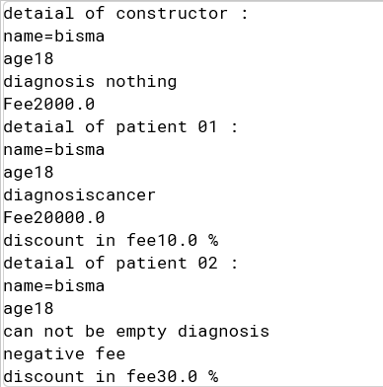

PROGRAM 02
1. class Employee {
2. protected String name;
3. private double salary;
4.
5. // Constructor
6. public Employee(String name, double salary) {
7. this.name = name;
8. this.salary = salary;
9. }
10.
11. // Method to calculate 10% bonus
12. public double calculateBonus() {
13. return salary * 0.10;
14. }
15.
16. // Method to display employee info
17. public void displayInfo() {
18. System.out.println("Name: " + name);
19. System.out.println("Salary: " + salary);
20. }
21.
22. // Getter for salary (needed by Manager)
23. protected double getSalary() {
24. return salary;
25. }
26. }// Manager.java
27. class Manager extends Employee {
28. private int teamSize;
29.
30. // Constructor
31. public Manager(String name, double salary, int teamSize) {
32. super(name, salary);
33. this.teamSize = teamSize;
34. }
35.
36. // Override bonus method to give 20%
37. public double calculateBonus() {
38. return getSalary() * 0.20;
39. }
40.
41. // Override displayInfo to include team size
42.
43. public void displayInfo() {
44. super.displayInfo();
45. System.out.println("Team Size: " + teamSize);
46. }
47. }
48. public class Main {
49. public static void main(String[] args) {
50. Manager mgr = new Manager("BISMA", 80000, 5);
51. mgr.displayInfo();
52. System.out.println("Bonus: " + mgr.calculateBonus());
53. }
54. }
55.
OUTPUT
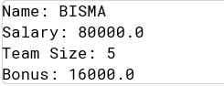
PROGRAM 03
1. class Vehicle {
2. protected String type;
3.
4. public Vehicle(String type) {
5. this.type = type;
6. }
7.
8. public void startEngine() {
9. System.out.println(type + " engine is started");
10. }
11.
12. public void move() {
13. System.out.println(type + " is moving");
14. }
15. }
16.
17. // Land vehicle class
18. class LandVehicle extends Vehicle {
19. protected int wheelCount;
20.
21. public LandVehicle(String type, int wheelCount) {
22. super(type);
23. this.wheelCount = wheelCount;
24. }
25.
26. public void move() {
27. System.out.println(type + " is moving on " + wheelCount + " wheels");
28. }
29. }
30.
31. // Derived Car class
32. class Car extends LandVehicle {
33. private String model;
34.
35. public Car(String model) {
36. super("Car", 4);
37. this.model = model;
38. }
39. public void move() {
40. System.out.println(model + " is driving smoothly on the road");
41. }
42.
43. public void displayCarInfo() {
44. startEngine();
45. move();
46. System.out.println("Car Model: " + model);
47. System.out.println("Wheel Count: " + wheelCount);
48. }
49. }
50.
51. public class Main1 {
52. public static void main(String[] args) {
53. Car myCar = new Car("Tesla");
54.
55. System.out.println("Testing vehicle methods:");
56. myCar.startEngine();
57. myCar.move();
58.
59. System.out.println("\nCar information:");
60. myCar.displayCarInfo();
61. }
62. }
63.
OUTPUT
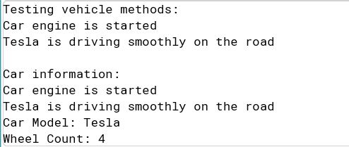
PROGRAM 04
1. public class Employee{
2. String name;
3. double salary;
4. double Hourofwork;
5. Employee(String name,double salary,double Hourofwork)
6. {
7. this.name=name;
8. this.salary=salary;
9. this.Hourofwork=Hourofwork;
10. }
11. public void showinfo(){
12. System.out.println("name="+name);
13. System.out.println("salary="+salary);
14. System.out.println("Hours="+Hourofwork);
15. }
16. public void addTosalary(){
17. {System.out.println("salary is icrease by 20%");
18. System.out.println("new salary="+(salary+(salary*0.20))); }
19.
20. }
21. public void deductFromSalary(){
22. System.out.println("salary is decrese by 5%");
23. System.out.println("new salary="+(salary-(salary*0.05)));
24.
25. }
26. public static void main(String[] args)
27. {
28. Employee obj1=new Employee("Bisma",20000,9);
29. Employee obj2=new Employee("javeria",20000,4);
30. obj1.showinfo();
31. if(obj1.Hourofwork>8)
32. {
33. obj1.addTosalary();
34. }
35. if(obj1.Hourofwork<5){
36. obj1.deductFromSalary();
37. }
38. obj2.showinfo();
39. if(obj2.Hourofwork>8)
40. {
41. obj1.addTosalary();
42. }
43. if(obj2.Hourofwork<5){
44. obj1.deductFromSalary();
45. }
46.
47. }
48. }
OUTPUT
